Experiment – 11
Question:
Change Hardware compatibility of a VM (Either by clone/create new one) which is already created and configured, using virtual box.
Answer:
AIM: To modify hardware configuration of an existing VM.
SOFTWARE REQUIRED: Virtual Box, Host OS: Windows
PROCEDURE:
STEP 1: Open VirtualBox
Click Start → Oracle VM VirtualBox
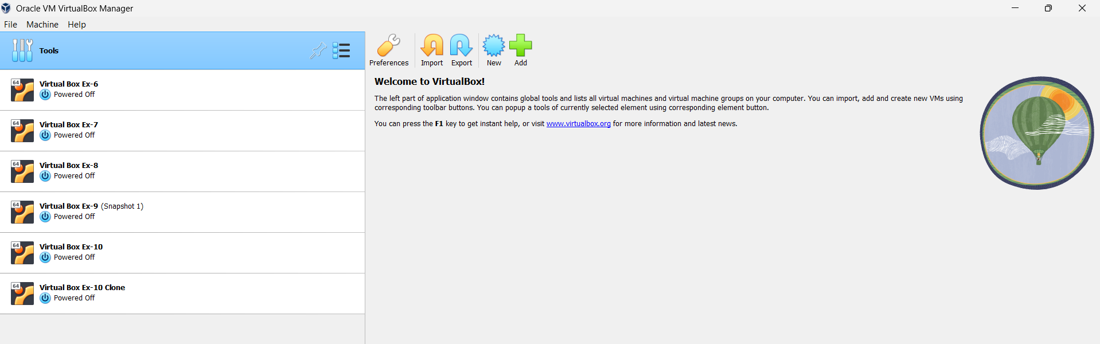

STEP 2: Create New VM
Click New
Name: Virtual Box Ex-11
Type: Linux
Version: Ubuntu (64-bit)
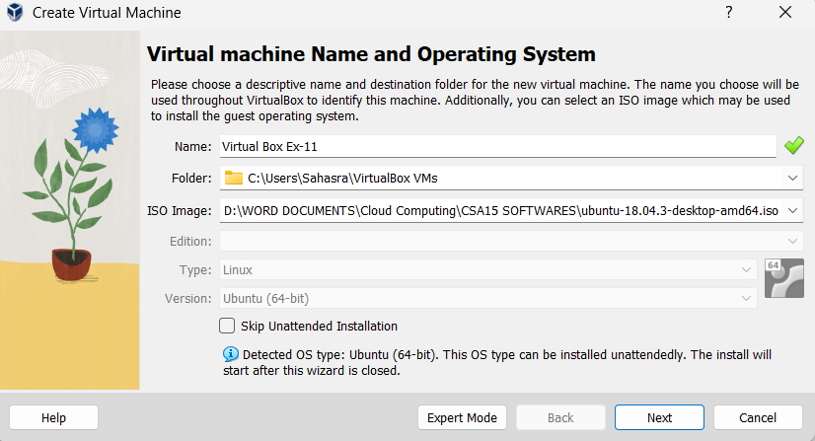
STEP 3: Select ISO File
Click ISO Image
Browse and select Ubuntu ISO
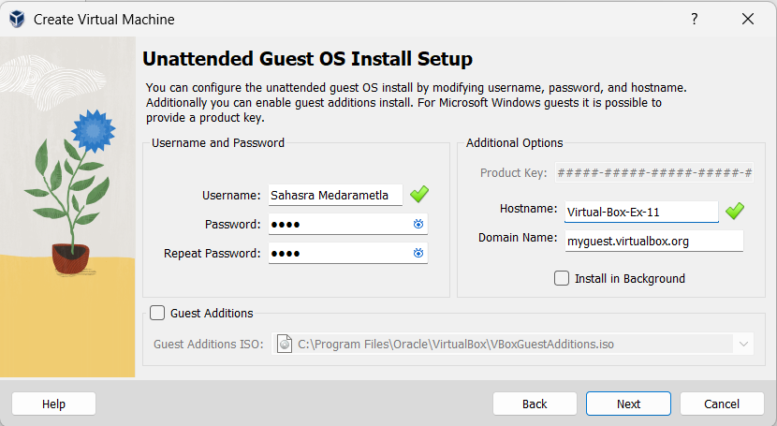
STEP 4: Set CPU = 1
Set Memory = 2048 MB

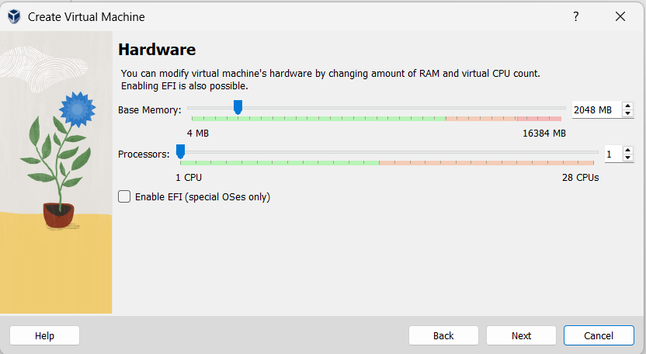

STEP 5: Set Disk Size
Verify disk = 25 GB
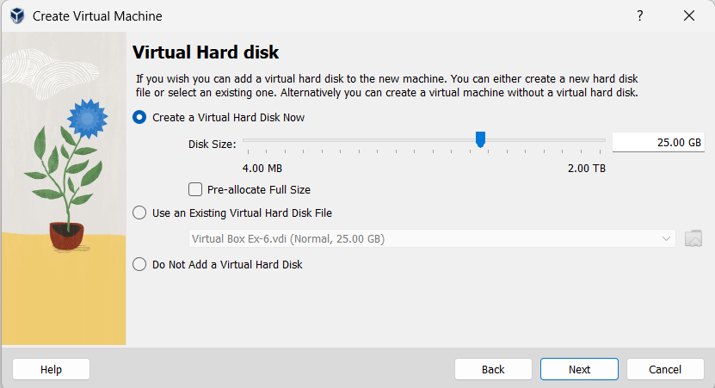

STEP 4: Finish Setup
Click Next → Finish
Click Start to run VM
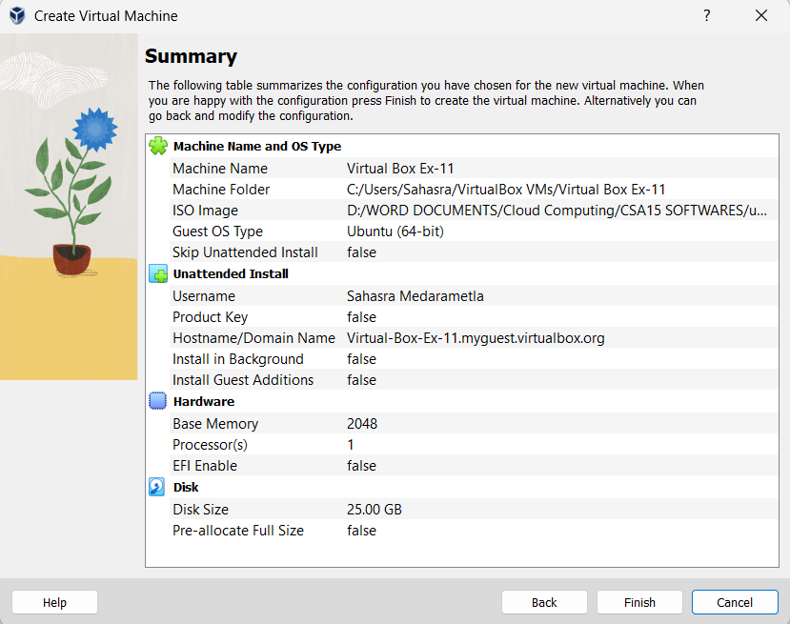
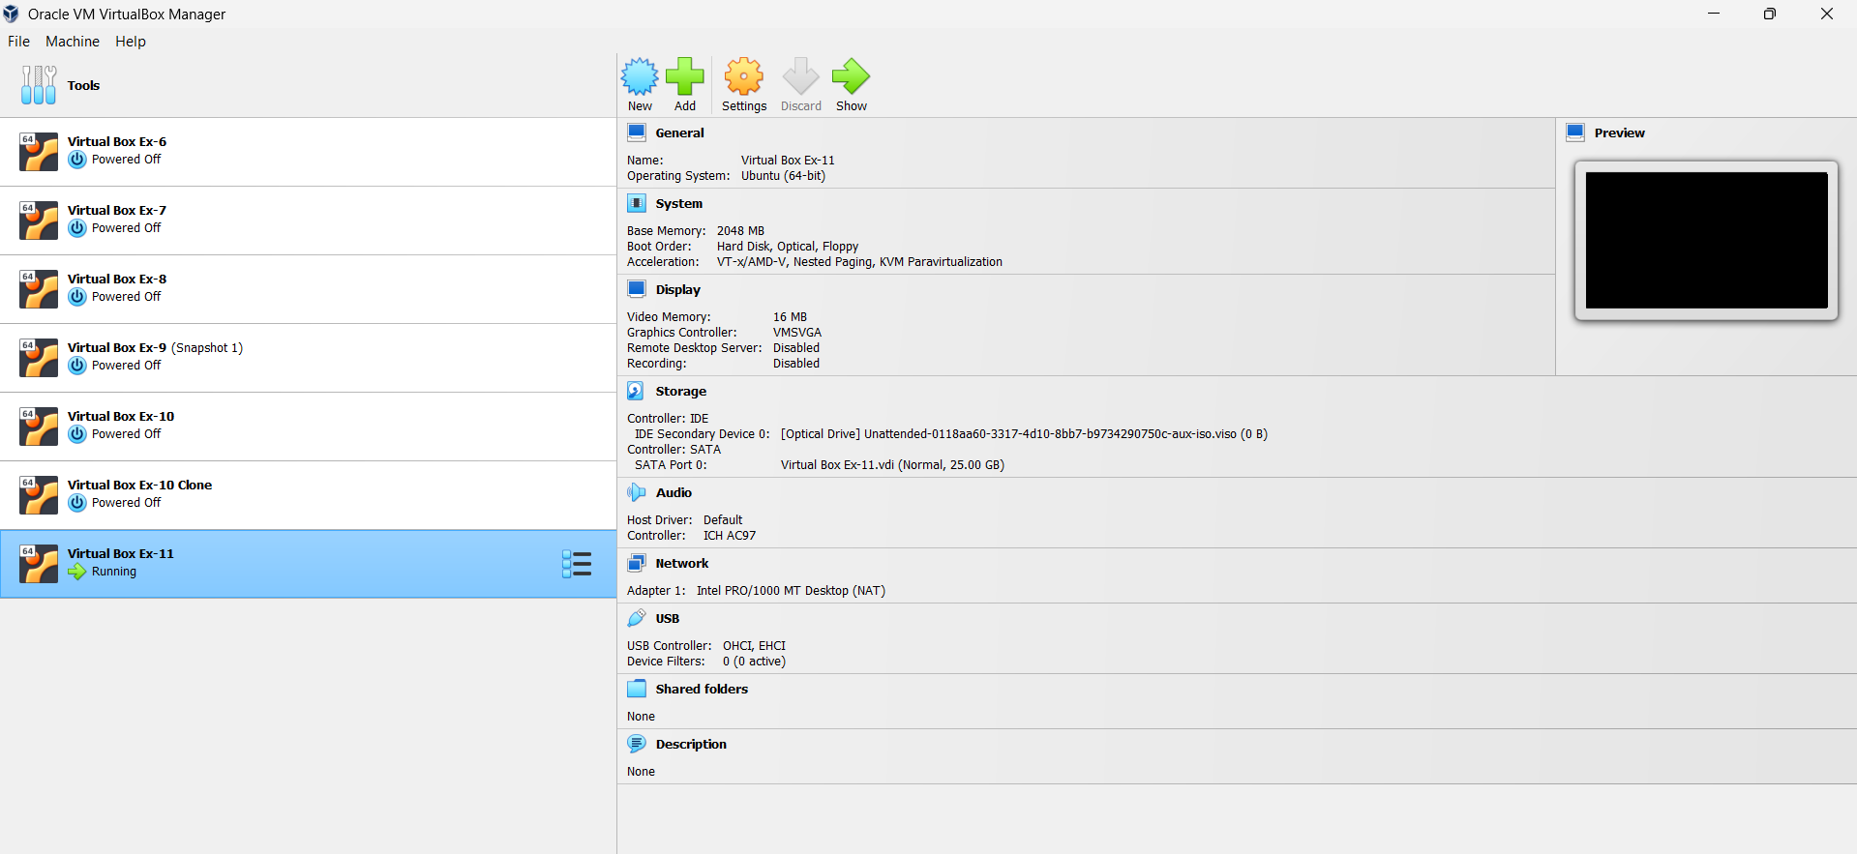
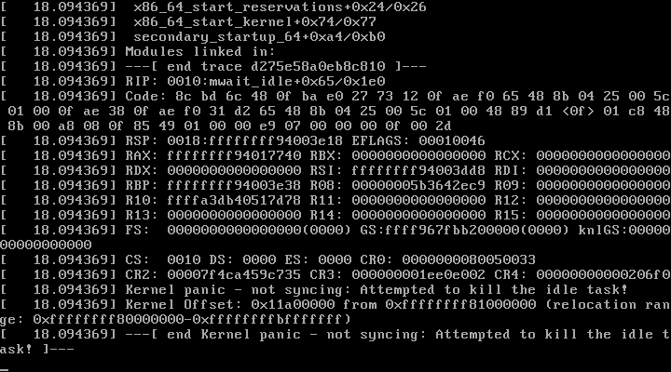
STEP 5: Power OFF VM
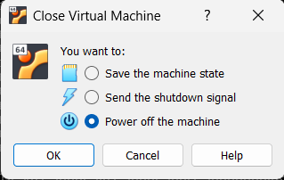
STEP 6: Open Settings
Select VM → Settings
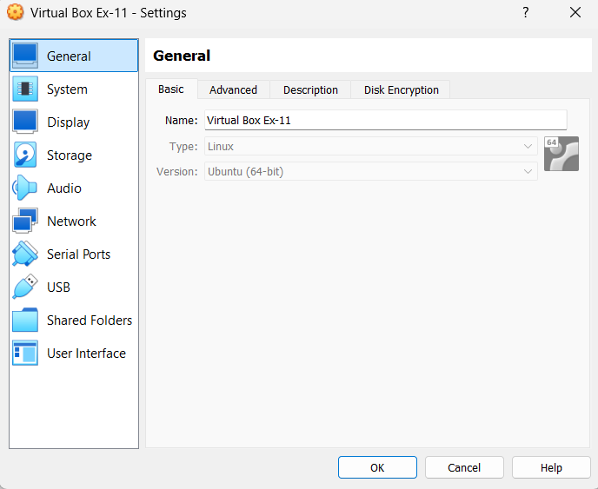
STEP 7: Change Hardware Options
You can modify any of these:
Processor cores
- System → Processor → Increase/decrease CPU
Display memory
- Display → Increase Video Memory
Enable PAE/NX
- System → Processor → Enable PAE/NX
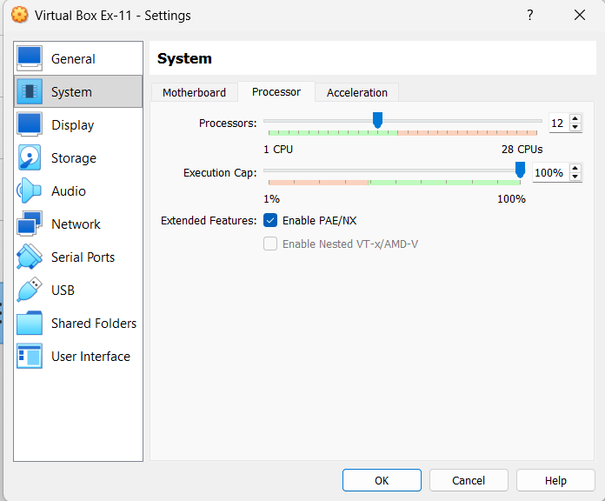
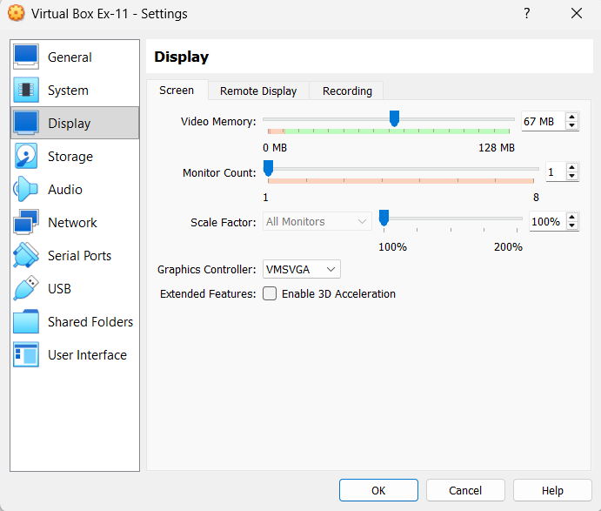
STEP 8: Apply Changes
Click OK
Start VM
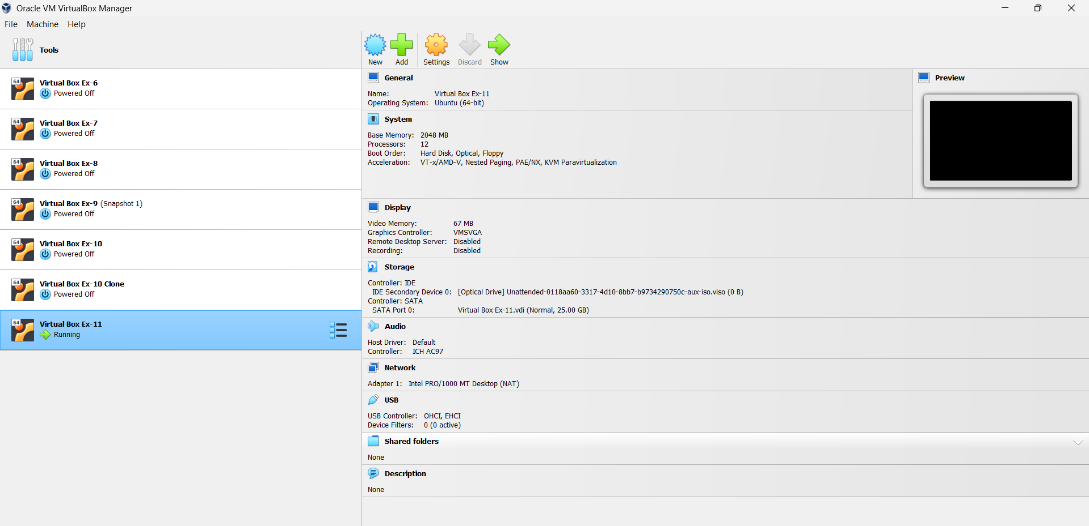

RESULT: Hardware configuration of VM modified successfully.

